**Chapter 11 - Digital Logic**

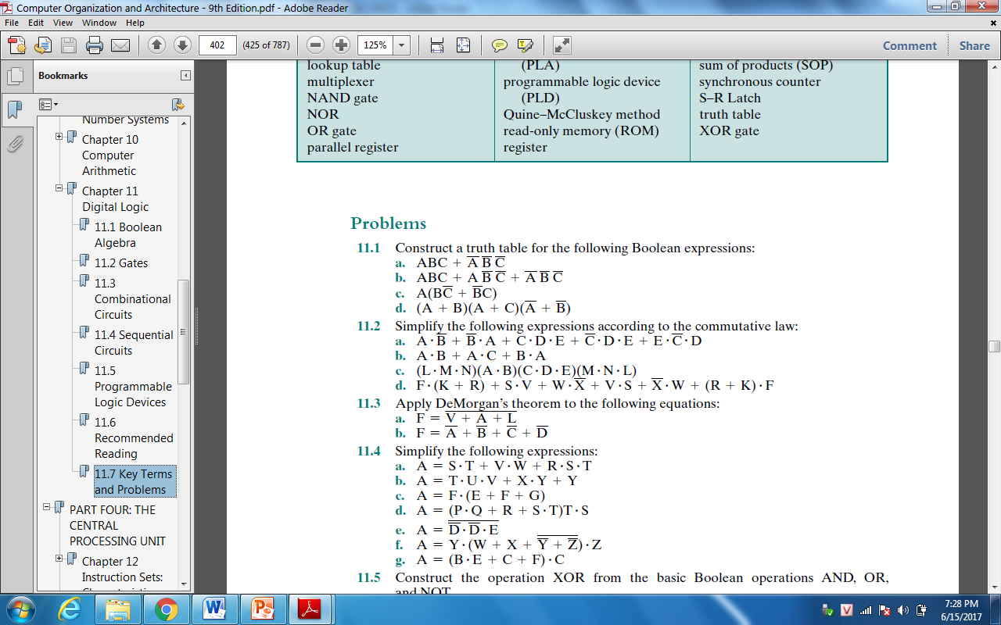

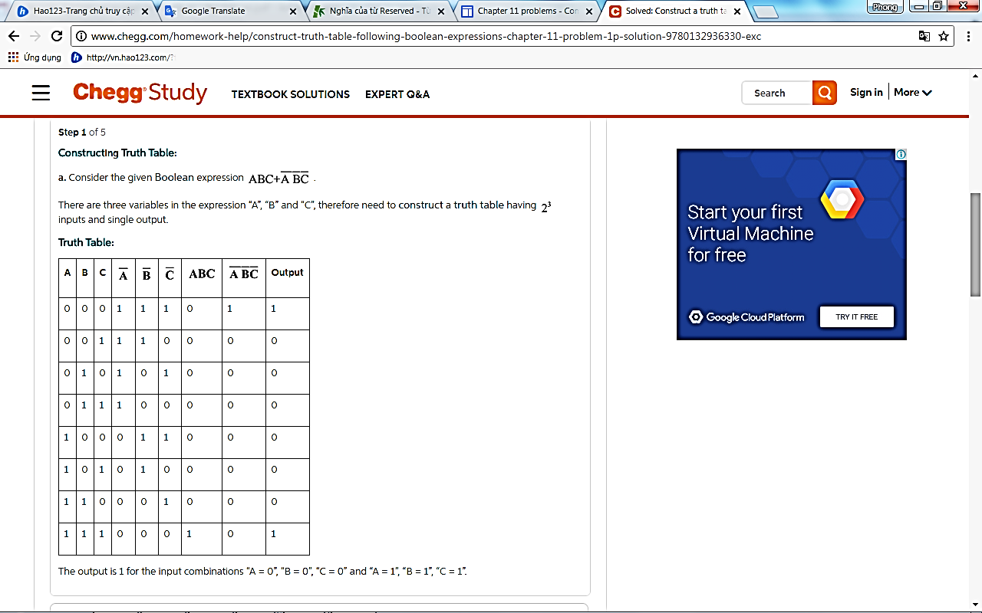

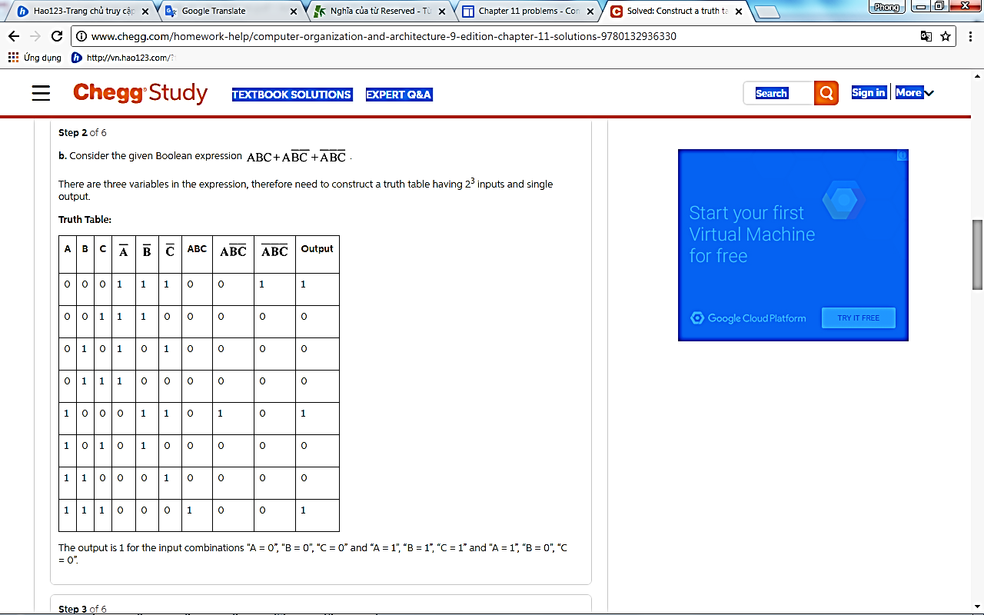

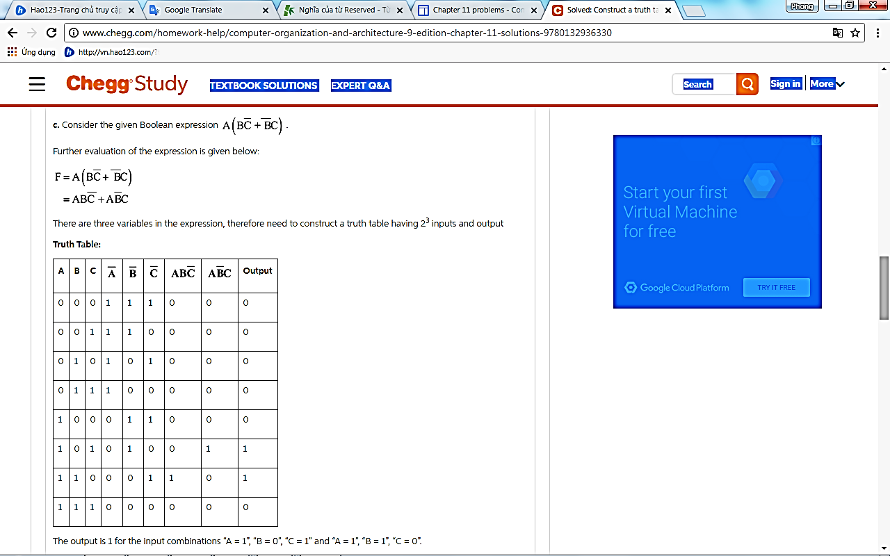

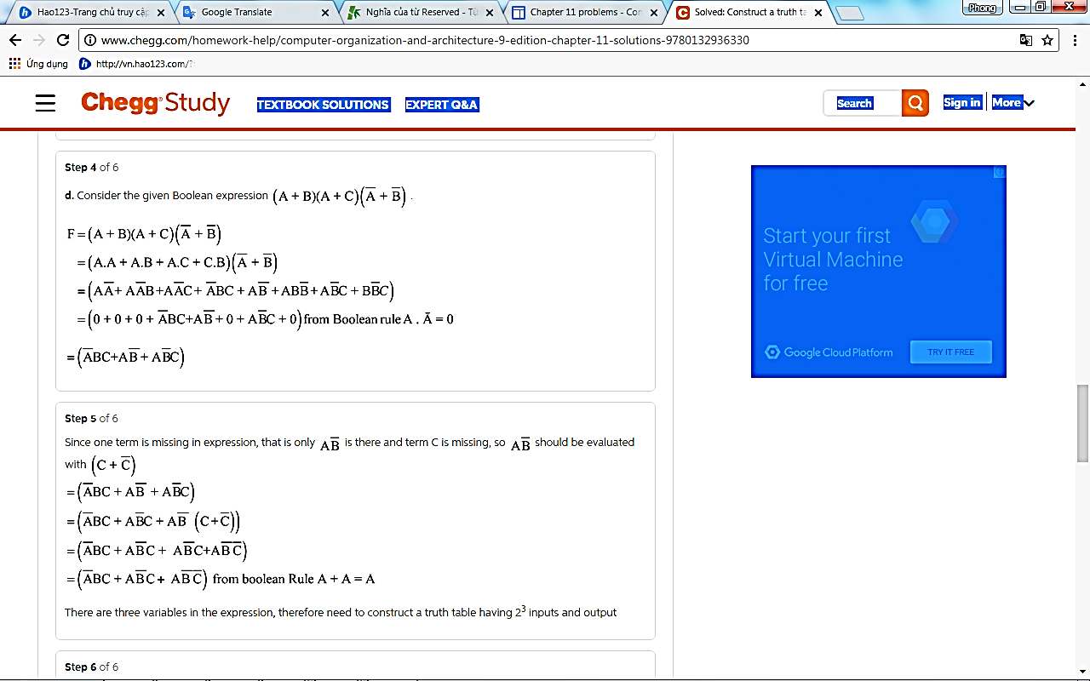

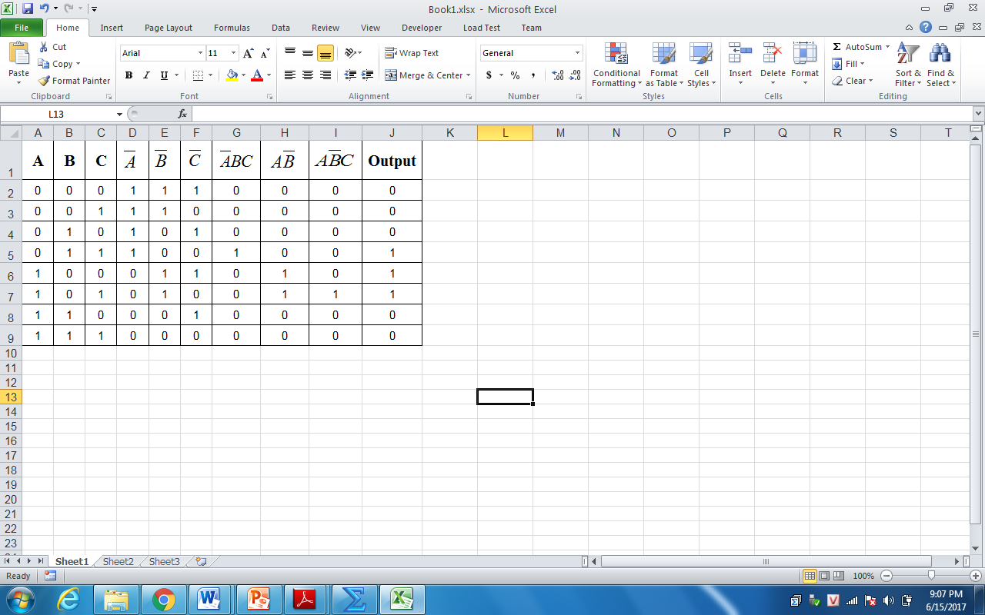

The output is 1 for the input combinations “A=0”, “B=1”, “C=1”; “A=1”, “B=0”, “C=0”; and “A=1”, “B=0”, “C=1”;

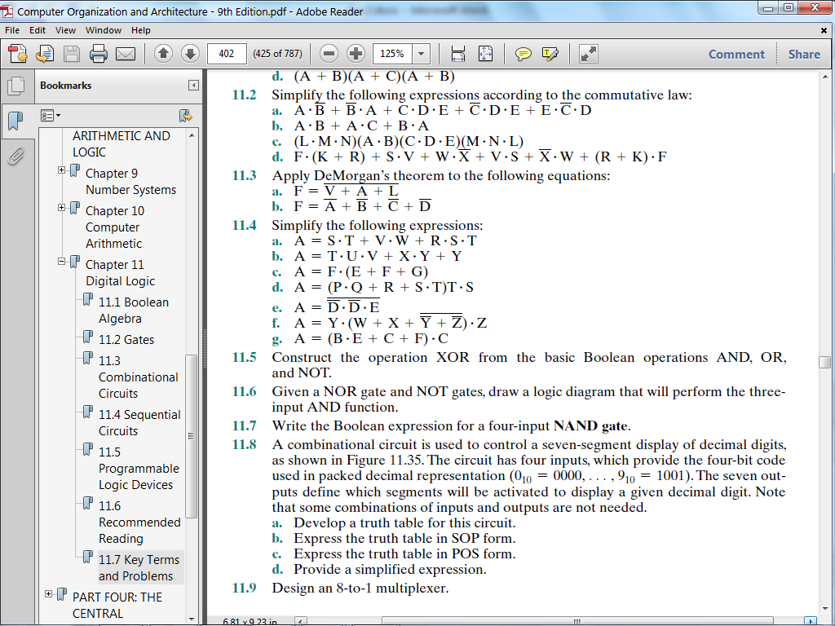

**Answers to Questions**

1. 
2. 
3. 
4. 

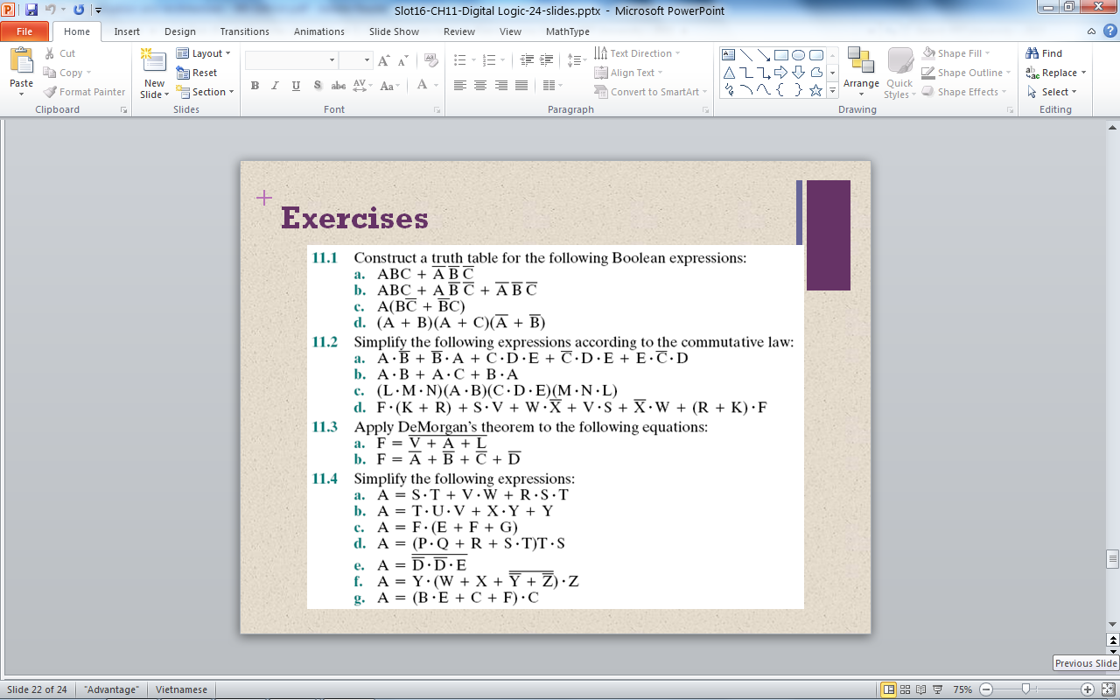

**Answers to Questions**

1. 
2. 

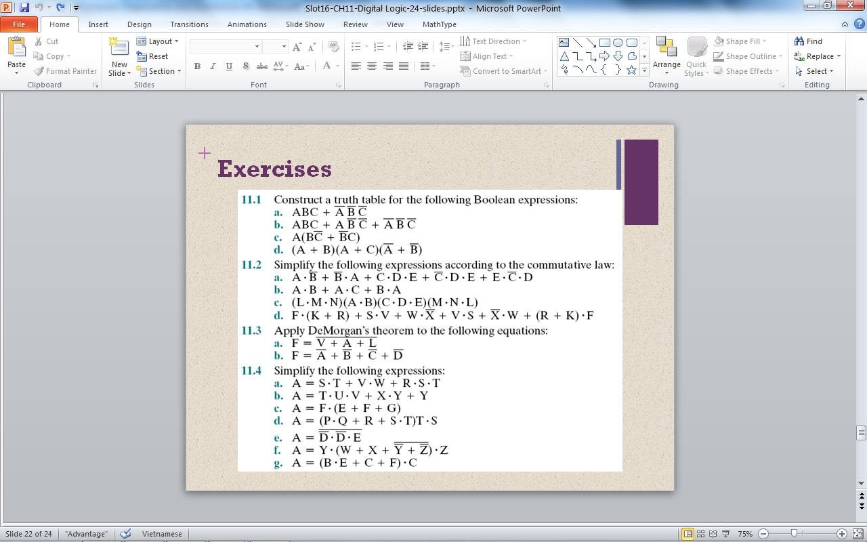

**Answers to Questions**

1. 
2. 
3. 
4. 
5. 
6. 
7. 

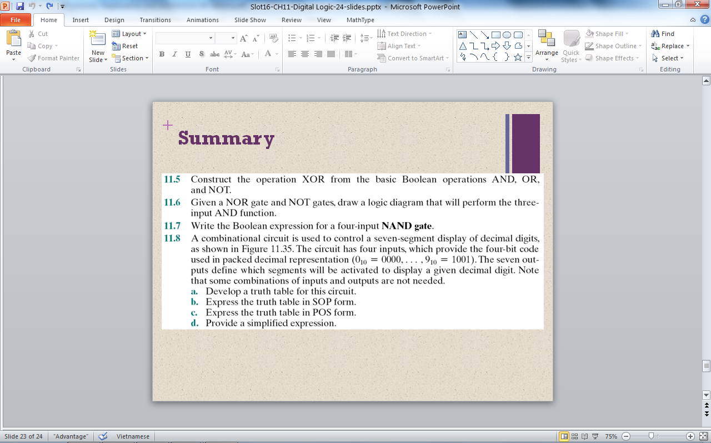

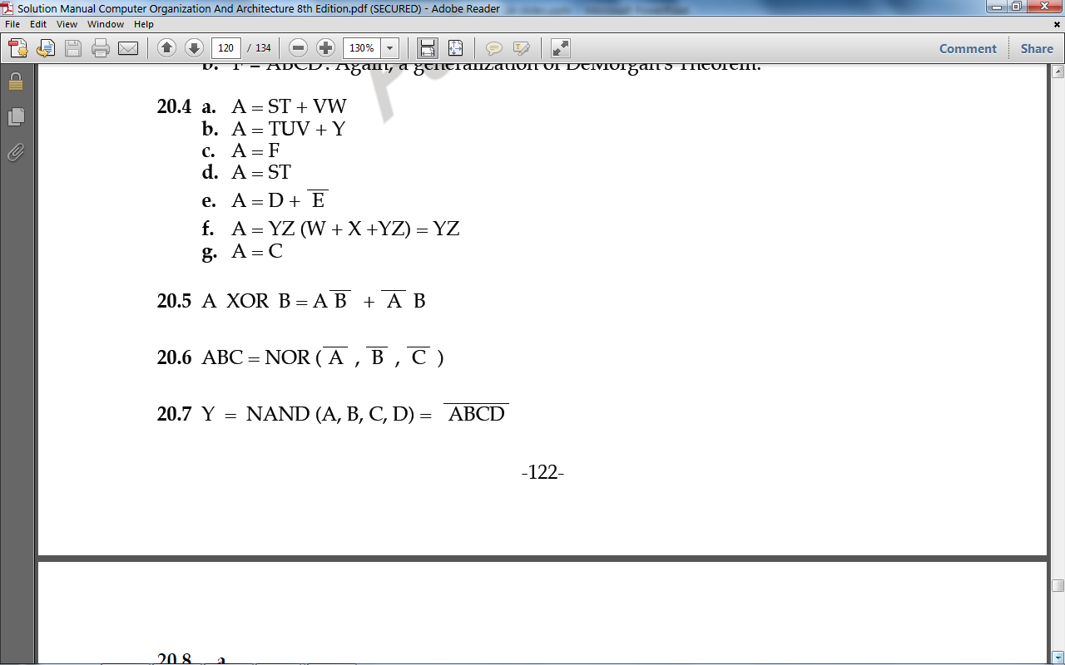

**5**,

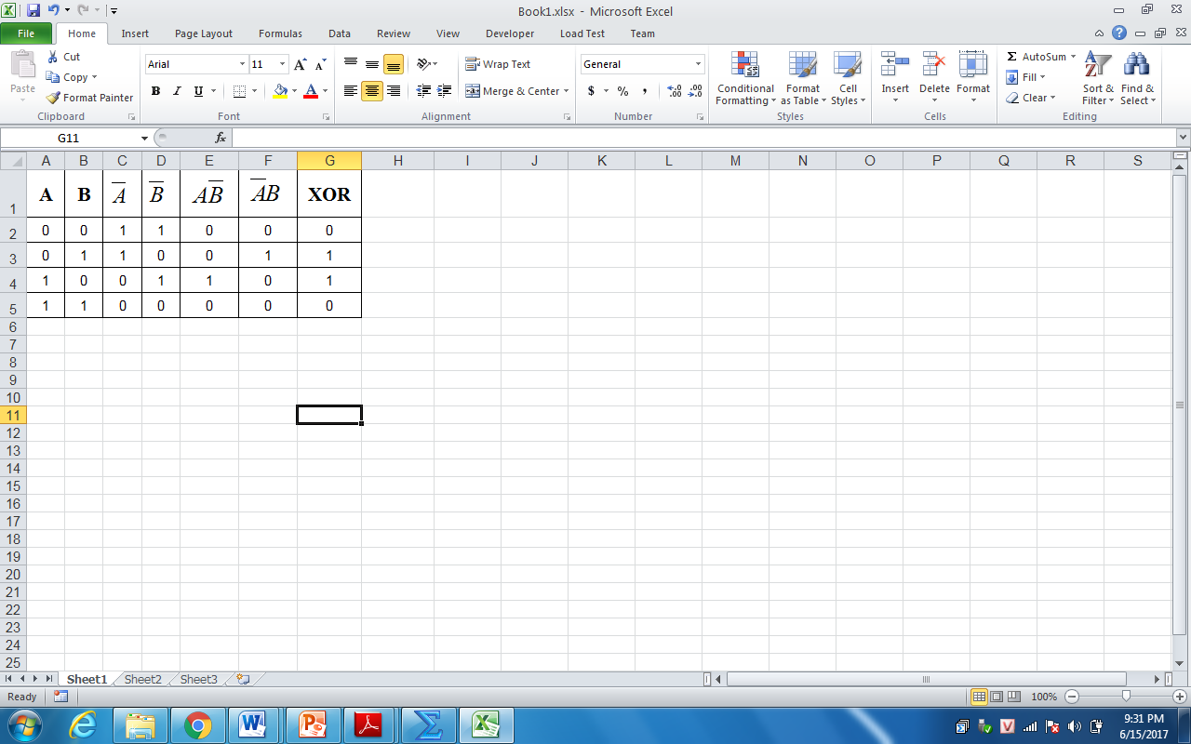

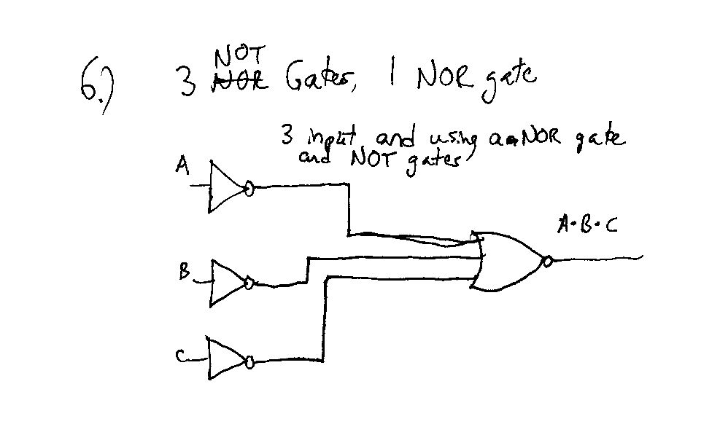

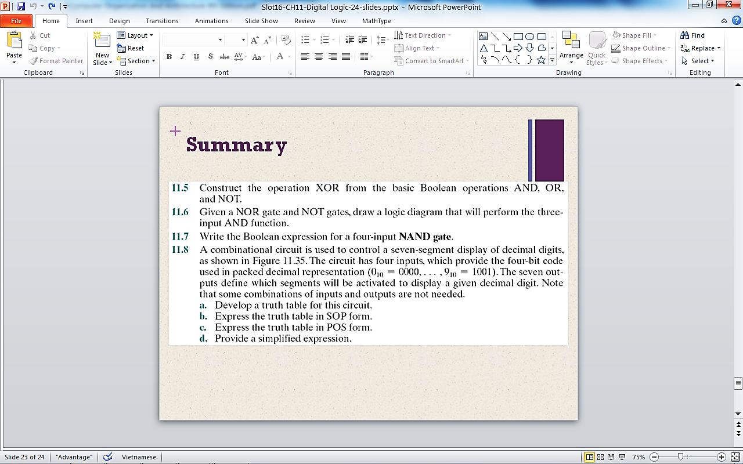

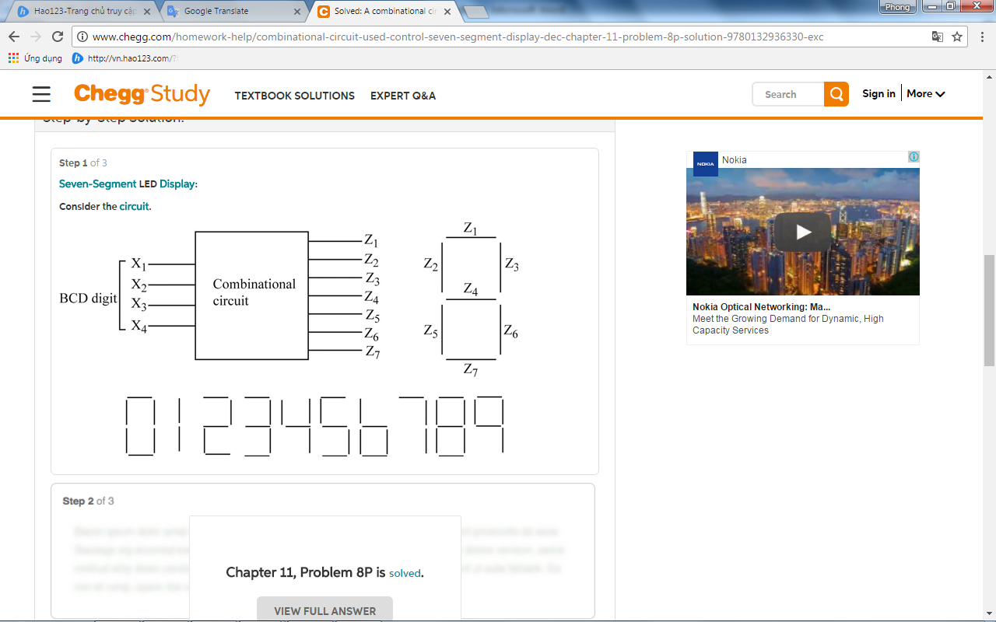

**Answers to Questions**

1. **Truth table**: The circuit has **4 inputs**: X1, X2, X3, X4 for BCD number and **7 outputs**: Z1, Z2, Z3, Z4, Z5, Z6, Z7 of a 7-segment LED adapt to inputs, so that the segments burns make a **decimal number** correctly with the BCD code at the input. The **truth table** of the 7-segment decoding circuit:

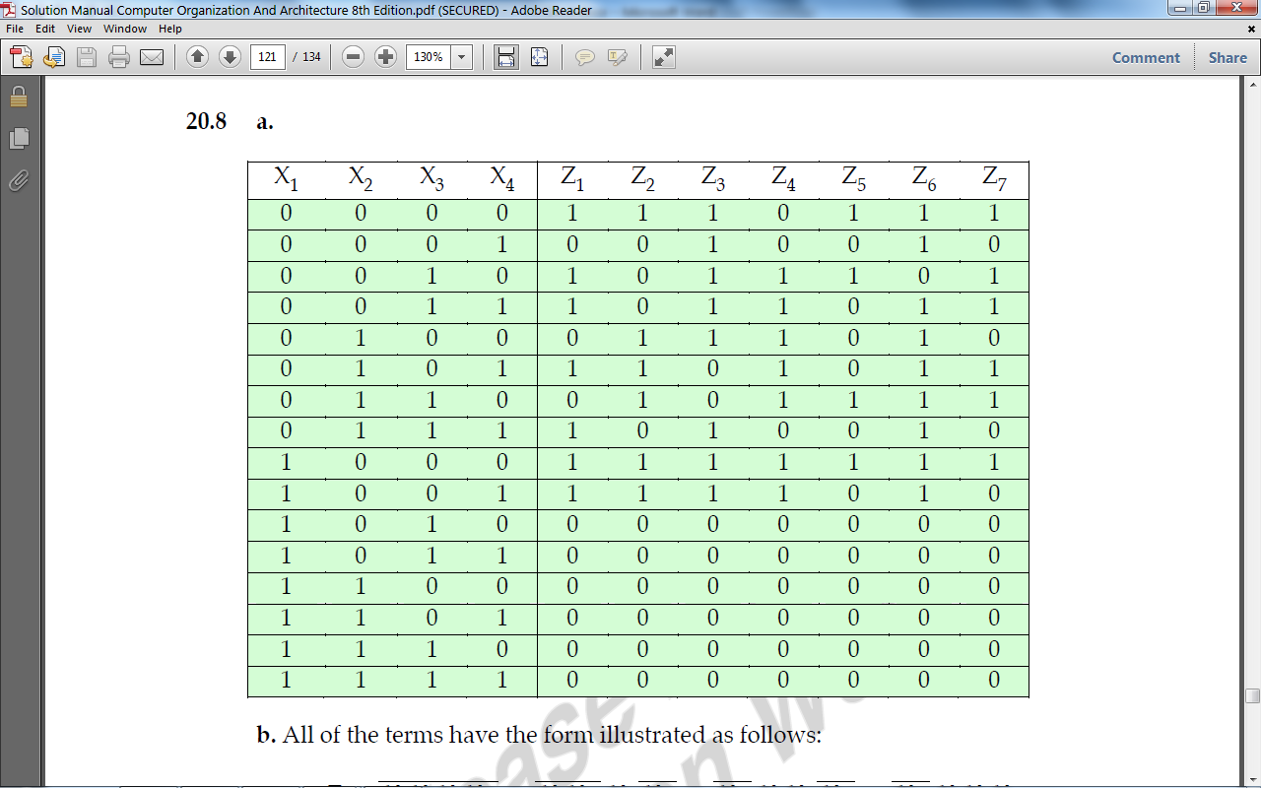

1. **SOP form**: All of terms have the form illustrated as folows:

, for example:



1. **POS form**: Whereas the SOP form list all combinations that produce an output of 1, the POS form lists all combinations that produce an output of 0.

, for example:



1. **Provide a simplified expression.**







<http://www.chegg.com/homework-help/computer-organization-and-architecture-9-edition-chapter-11-solutions-9780132936330>